# Basics

## Estimation of the direction of arrival with a Radar array

Using techniques like FMCW, it is possible to estimate range and velocity of objects using Radar sensors. For complete knowledge oft he environment of the Radar sensor, it is however necessary to estimate the angle of the objects along with the range.

Angle estimation, also called the estimation of the direction of arrival (DOA) of the reflected Radar signal, requires the use of multiple antennas in an array, as the angle estimation is based on the differences in the arrival time of the reflected wave front at the individual antennas.

[Fig.1.1 Show incoming wave front with multiple antennas]

As you can see in fig. 1.1, a wave front that is not parallel to the array will result in different travel times of the signal to the individual antennas. This leads to phase differences of the received signals at the individual antennas, when evaluated at the same time.

The signals at the individual antennas are then formulated as

[Eq. 1.1 Single antenna signal with delay depending on scalar product of position vector and angle vector]

In general, the

## 1.2 Expansion to MIMO antennas

Multiple-Input-Multiple-Output (MIMO) antennas are a method to design arrays with a higher diversity as well as a higher virtual aperture.

The virtual aperture is the value [Z/lambda], which is the physical aperture of the array normalized over the wavelength. Using multiple transmitting antennas will increase the virtual array aperture of the antenna array by the virtual array of the transmitting antennas.

Fig. 1.2 shows a visualization of a simple MIMO array with a visualization of the expanded aperture.

[Fig. 1.2 Show a transmitting array and a receiving array. Then show the resulting virtual array (e.g. replicate receiving array at each transmitting antenna)]

## 1.3 Multi carrier signal model

## 1.4 Maximum likelihood estimation

## 1.5 Beam pattern

*[Show example for resulting beam pattern.*

*Point out the properties of the array pattern which are used in this thesis:*

*• Beamwidth (not 3dB beamwidth, but to the 1st minimum)*

*• Sidelobe region (Discuss the reason to take the whole non-main peak region as a sidelobe region)*

*• Sidelobe level]*

## 1.6 Performance metrics

[CRB and SLL, similar to Lange]

## 1.6 Combined CRB of multi carrier arrays for range and angle

In section 1.4 it was shown that the estimation of range and angle can not be separated. However, [Michael-CRB] demonstrates that the CRB of range and angle estimation can be separated if the origin of the coordinate system is set to the location of the array centroid.

In [Michael-CRB] the CRB has the form

[show matrix form from paper, but with the E matrix replaced]

The origin of the coordinate system can be set to the location of the array centroid by performing the operation

[P_decoupled = P – p_centroid]

or for MIMO arrays

[P_decoupled = P – 2*1_vector * p_centroid]

This can be easily done, as it only affects the coordinate system used in the estimation and does not impose any constraints or limits on the rest of the system.

When this condition is fulfilled, the CRB of angle and range is decoupled. This means that the CRB matrix becomes block diagonal as in eq. […].

[Equation of CRB with p_centroid = 0]

The top left block in eq. […] is the CRB for the angles (two-dimensional, as general angle estimation has two angles), while the bottom right block (1x1) is the CRB for the range estimation. Now, that the CRB of range and angle estimation are decoupled, they can be studied individually.

## 1.7 Individual CRB of multi carrier arrays for angle

Using the results of [Michael-CRB], the CRB for angle estimation can be derived for the decoupled case.

[Eq. … Important part, since this adds my own results]

# On Grating Lobes

## Grating lobes

Grating lobes are side lobes of the same size as the main lobe. They are characterized by a visible periodicity in the beam pattern as it can be seen in fig. […]. Naturally, grating lobes within the ROI are very undesirable, as they lead to ambiguous estimation results, since it is impossible to discern between the main lobe and the grating lobe.

[Fig. Beam pattern mit grating lobes]

A standard ULA with a spacing of d=lambda/2 does not show grating lobes within the region of u=-1,1. The edge cases u=-1 and u=1, are the first occurrence of grating lobes for such arrays.

[Fig. beam pattern for ULA]

Widening the spacing d of an ULA, will introduce grating lobes within the region u=-1,1. For example a spacing d=lambda, which is double the value of a standard ULA, will result in a beam pattern as in fig. […]. It can be seen, that the unambiguous ROI of an ULA with a doubled spacing is half the size of the ROI of the standard ROI.

[Fig. beam pattern for ULA with d=2 * d_standard = lambda]

### 2.1.1 Relationship between angle estimation and Fourier transformation

For an easier understanding of grating lobes, it is useful to observe the parallels between angle estimation and Fourier transformations. In most cases, Fourier transformations are used to generate frequency spectrums from signal values sampled in time. This frequency spectrum can then be used to estimate the dominating frequencies.

In the case of angle estimation, the antenna positions are equivalent to the time at which samples of the signal are taken, while the beam pattern is equivalent to the frequency spectrum. Instead of estimating the dominating frequencies, it is the angles that are estimated.

This analogy between angle estimation and Fourier transformation becomes clearer by looking at the signal model of angle estimation with an ULA (in eq. …) and the transformation matrix of discrete Fourier transformation (in eq. …). A linear array and a one-dimensional DFT are used here for an easier comparison, but they can be expanded to higher dimensional arrays and DFTs with the same result.

The signal at an ULA (single carrier case) is

[Eq. signal at ULA (single carrier)

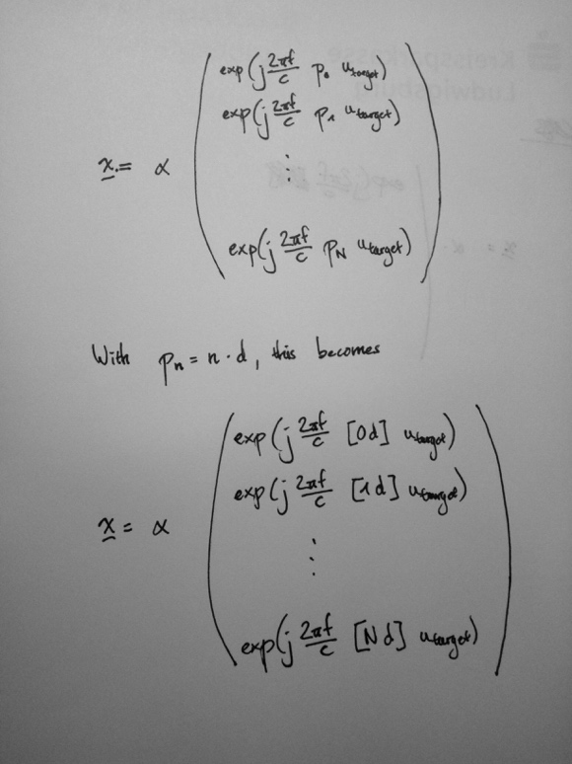

]

Discretizing the space of angles would make it possible to rewrite the signal as

[Eq. signal with discretized angles and “sensing matrix”



]

When comparing the sensing matrix A with the transformation matrix W of DFT, the relationship between the transformation from radar signal to beam pattern and the transformation from time signal to frequency spectrum becomes obvious.

[Eq. of transformation matrix in DFT]

## Grating lobes in single carrier non-uniform arrays

As the Fourier transform and the radar signal sensing are analogous, it is possible to study the effect of non-uniform arrays on the non-ambiguous ROI by studying the effect of non-uniform sampling in time on the bandwidth of the Fourier spectrum.

A regular Fourier transform with uniform sampling can be written as

[Eq. Fourier]

with a bandwidth of

[Eq. f_max = f_sample and f_sample = 1/delta_t]

for complex signals.

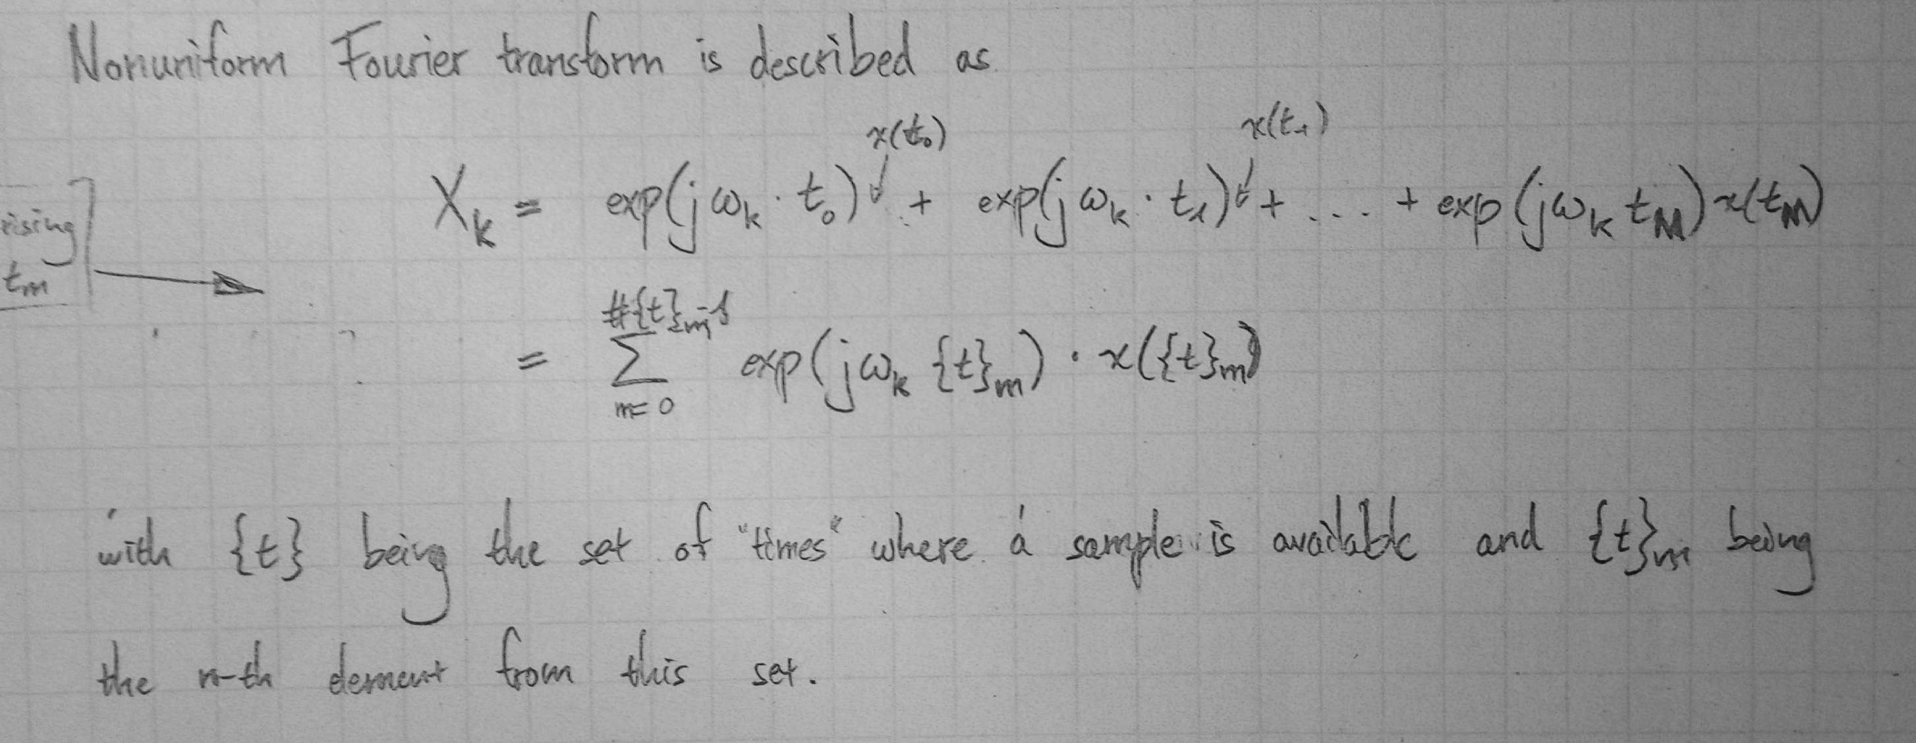

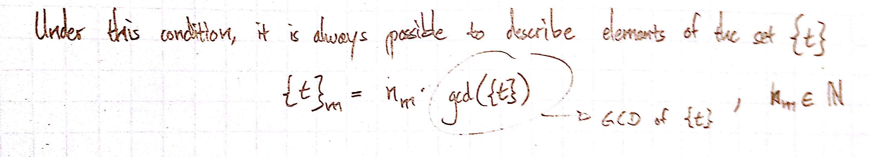

With gcd({t}) being the function that gives the greatest common divisor of the numbers in the set {t}.

While in theory it is possible for a set of numbers to have no GCD, if this set contains irrational numbers, it is assumed throughout this thesis that all numbers are discrete with the minimum GCD being the machine precision of the number’s representation on the computer.

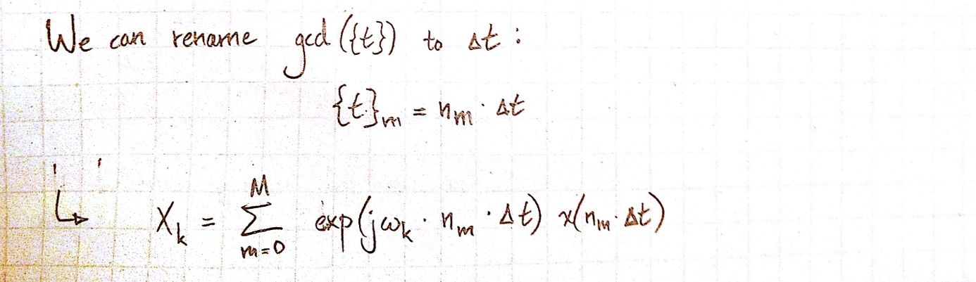

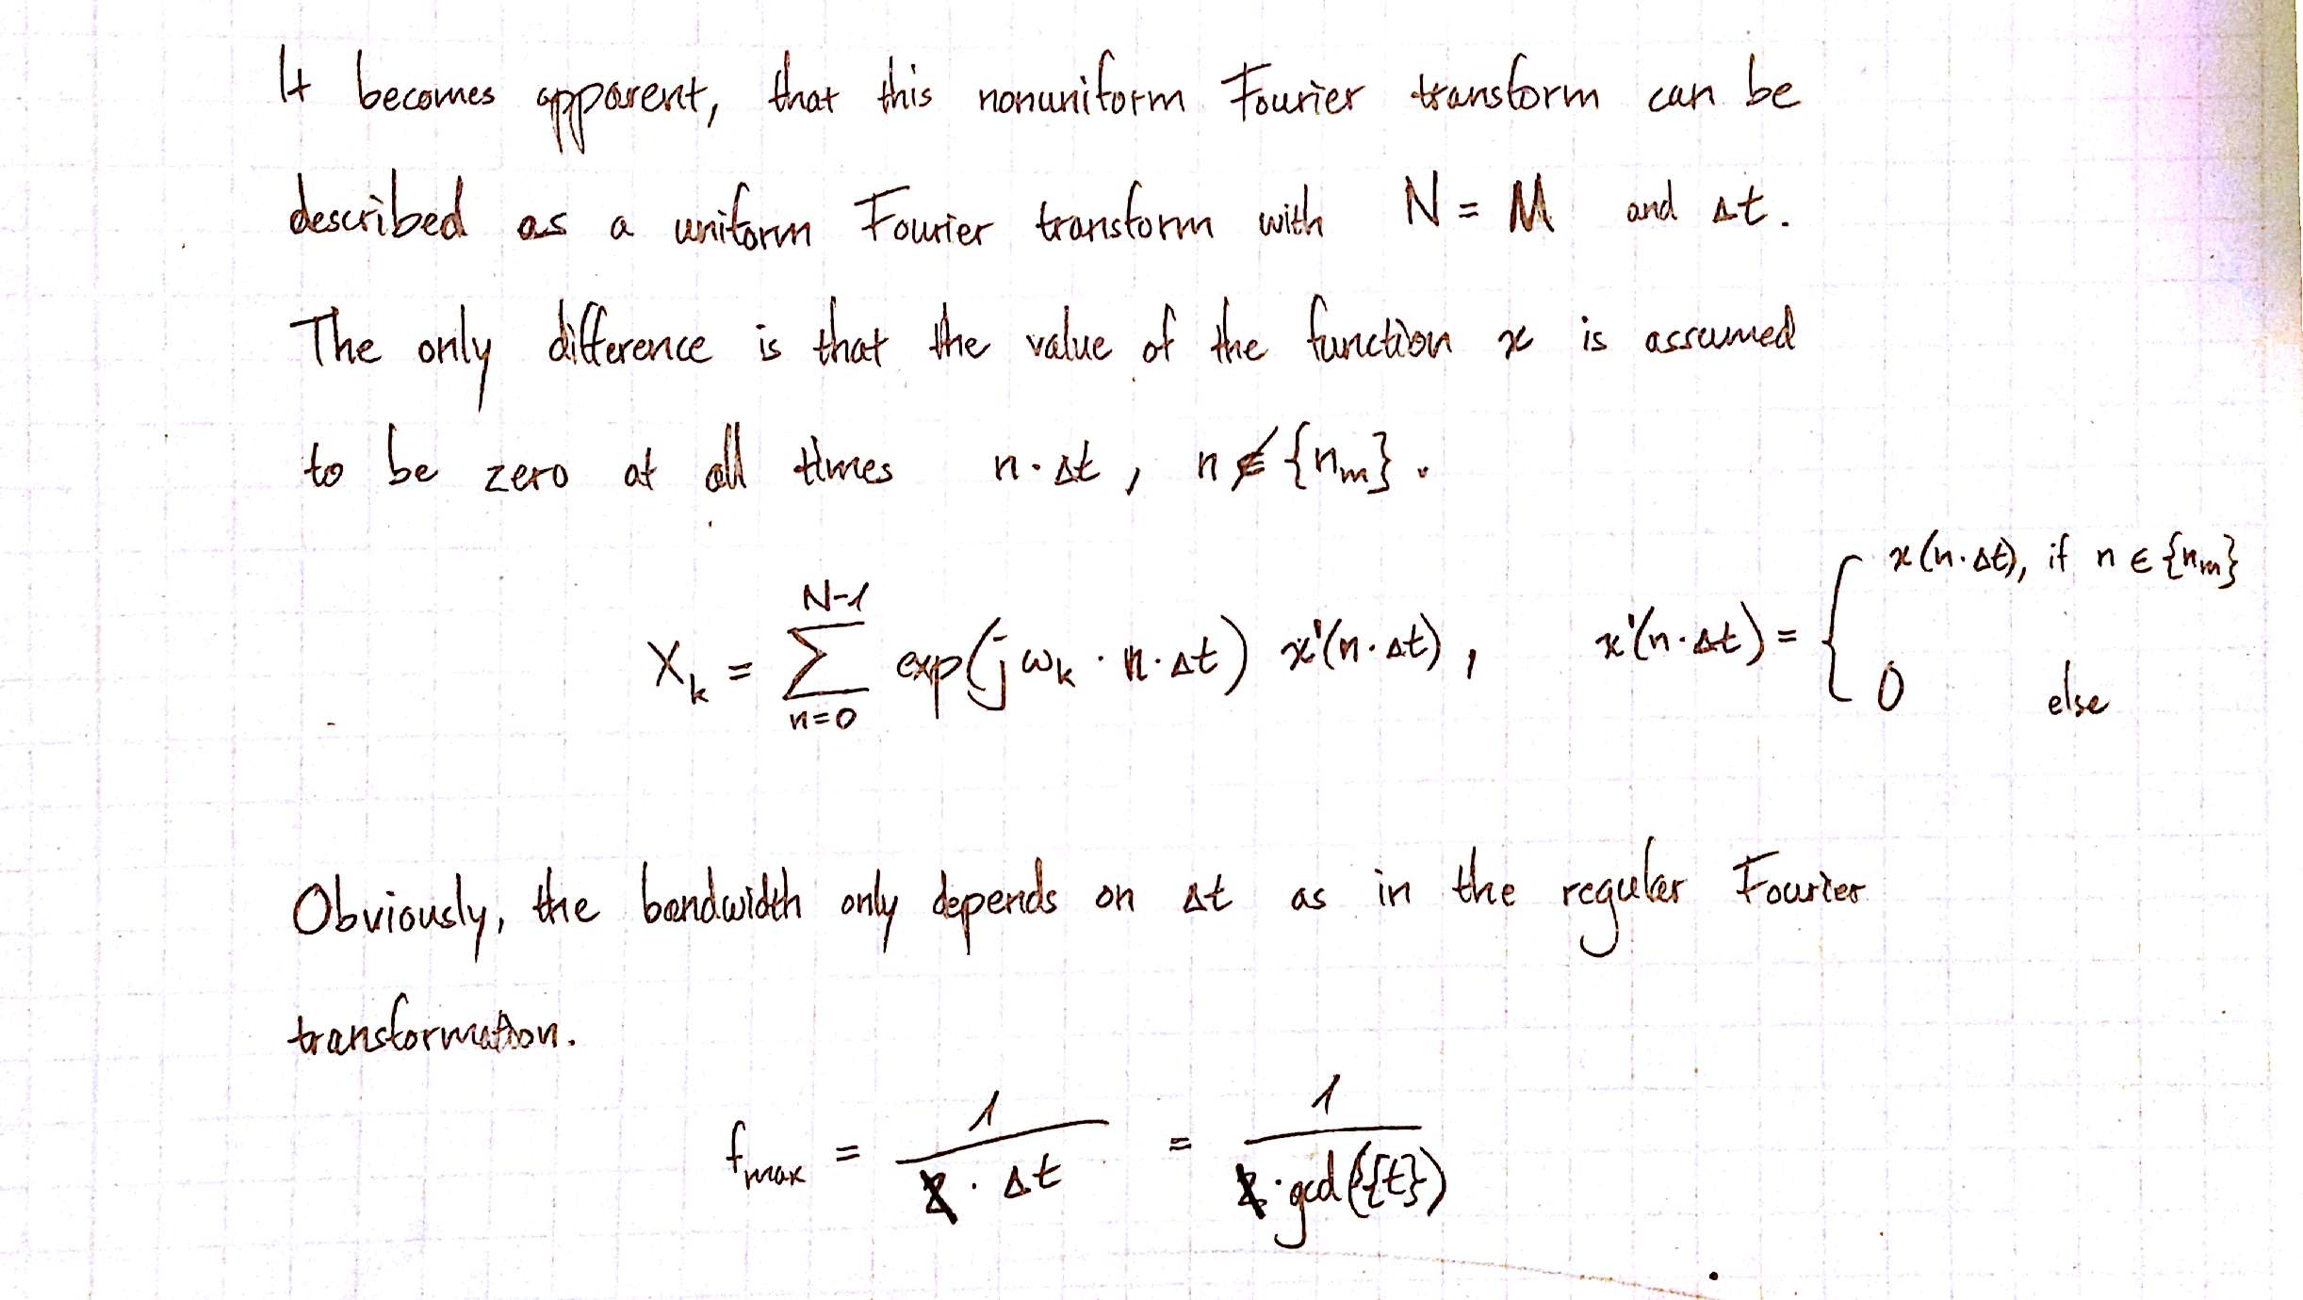

[… Connect bandwidth with ROI]

## 2.3 Grating lobes in multicarrier systems

# Overview of models for the optimization of antenna array for angle estimation

[give a short overview of the different models: CS, Sparse Sensing, Continuous Optimization]

# Discrete models

[note how discrete models work using the origin ULA etc. Fill UL slots with antennas. Randomly (CS) or deterministically (Sparse Sensing).]

## Compressive Sensing

* + 1. Basics of Compressive Sensing

*Explain the basics of compressed sensing.*

* *General concept with sparse signal -> transformation -> selection (under sampling) -> received signal*
* *The criteria for successful CS reconstruction*
  + *Coherence*
  + *Restricted Isotropy Property (RIP)*
    1. The CS model for multi carrier DOA estimation
       1. The sparse parameter space

*Describe the following points:*

* *The sparse representation of the signal.*
* *It is important to make clear that the non-zero values in this vector do* ***not*** *represent the target parameters (angle, range), but their reflected power instead.*
* *The* ***target parameters are encoded in the location*** *of the non-zero values in the parameter space.*
  + - 1. Linearizing the signal space and the sparse parameter space
* *Remind the reader of the signal model and the resulting requirements enforced onto the sensing matrix, as well as the signal and parameter vector*
* *We have to split the frequencies and geometric positions of the antennas, because the frequencies are later necessary to know in the sensing matrix. This results in the signal space becoming a multidimensional space instead of a vector.*
* *Because of how CS theory is formulated, it is necessary to reshape the signal- and parameter-space* ***into vectors***
* *Show how the rule as to how the spaces were stacked here*
  + - 1. The sensing matrix A

*The resulting sensing matrix*

*• Show one small example*

*• Explain structured pattern in this matrix*

* + 1. Coherence and side lobe level
    2. The Q-Matrix

*Breakdown into calculation of Q-matrix. Show that this matrix is symmetric and „block Toeplitz“, because our parameter space is regularly spaced. This means that we only need to calculate the first row/columns of blocks to have complete knowledge of Q and thus the maximally possible SLL.*

## Sparse Sensing

* + 1. Sensor selection
    2. Discrete optimization

# Continuous models

* 1. Continuous Optimization Model for multi carrier arrays

*Introduce Continuous Optimization Model as used by O. Lange.*

*Use the visualizations from the 3-antenna model to show how the SLL makes the optimization non-convex and with many local minima. Use this as an argument to use a global optimization scheme: Genetic Algorithm (or Evolutionary Algorithm as it is called by Lange).*

*[Fig. CRB of 3 antenna model over the two moving antennas]*

*[Fig. SLL of 3 antenna model over the two moving antennas]*

*Show how it can be used with MC-systems. Point out, that grating lobes do not need to be added as an extra constraint, because they are covered in the sidelobe region.*

* 1. Genetic algorithm
     1. Basic algorithm

[Explain the basic genetic algorithm.]

* + 1. Application to multi carrier array optimization
       1. Applied constraints
       2. Calculation of SLL

Show the calculation of the sidelobe level.

* Calculation of the beamwidith (p2m):
  + (Bigger part) Heuristics to limit the region in which the beamwidth can be found with high probability (min. Beamwidth from 2-antenna array is a real limit. The upper limit from the ULA is a soft limit, as it is possible for arrays with very low positional variance to have a higher beamwidth) -> List the arguments that allow me to take the ULA limit as a hard upper limit. (ULA limit not far from real beamwidth. Not very problematic, as it is mostly used for the spacing that calculates the sidelobe level.)
  + Single optimization to find the value for beamwidth
* Calculation of the sidelobe level within the sidelobe region:
  + Grid spacing with follow-up by optimization